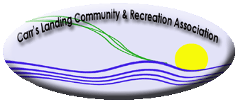

**Carr’s Landing Community &**

**Recreation Association**

Carr’s Landing Community and Recreation Association

Directors Meeting 7:00pm, Wednesday April 4, 2018

Carr’s Landing Fire Hall

**Agenda**:

!. Welcome, Present, Regrets.

2. Adoption of Agenda

3. Delegations

Heli Tourism. A report and update of Lake Country citizen presentations, concerns and status of this issue.

Discussion and direction for the CLC&RA directors.

Delegation Lake country Sail and Boating Association Kevin Bowles.

4. Adoption of meeting minutes

March 7, 2018 minutes

5. Business arising from the minutes

i. Survey Results, Review of results and suggestions for distribution.

ii Review of Directors meeting with Mayor, for planning Town Hall event.

iii. Review of discussion for expectations and preparation for DLC staff and Director meeting on April 13

iv. Discussion on expectations for the May Town Hall

v. Inclusion of the other community residents within Lake Country in relationship to our constitution.

6. Misc Directors Reports

Reports from any of the directors that need immediate discussion or approvals.

6. Old Business

i.

7. New Business

Gable Beach planning and priorities for summer 2018

Gable Beach Long Term planning

Community Event CLC&RA fund raising and inclusion of the Sail and Boating Association.

8. Other

Membership drive and communication

Bulletin boards use and upkeep.

???

9. Motion to Adjourn